2013
Lifestyle Challenge
Happier, Healthier YOU!

Sponsored by:
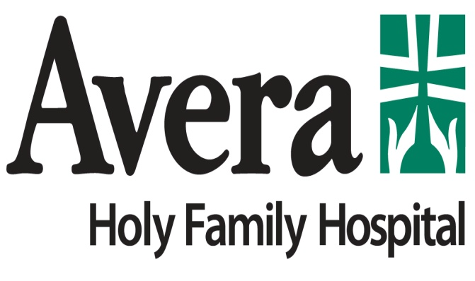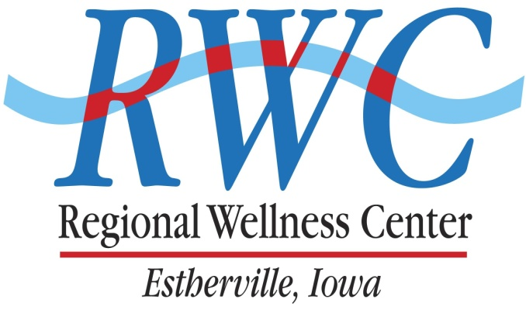

2013 Lifestyle Challenge
Sponsored by Avera Holy Family Hospital and the Regional Wellness Center
WHAT: Lifestyle Challenge – Helping you improve your health and wellness through weight loss and exercise.
WHEN: Initial weigh-in is Friday, January 11, 2013 @ the RWC
LENGTH: 12 Weeks (January 11 to March 29) with weekly weigh-ins on Fridays @ the RWC
WHO: TWO or more persons make up a team and may consist of male, female, co-ed, family, co-workers, etc….. anyone who wants to improve their health by exercising and/or losing weight. You do NOT need to be an RWC member to participate, however RWC members will have the advantage of matching the RWC amenities and their weight loss and exercise goals.
INVESTMENT: $35.00 per INDIVIDUAL (Employee Group Discount: $25.00 per individual if entry fee is paid by employer check- contact Jen Hough at Avera or Bob Grems at the RWC for employee group packets – employee groups do not need to be on the same team or with fellow employees – just need to have entry fee paid by employer check).
What you get for your investment
- Weekly weigh-ins at the RWC to keep you accountable. Weigh-ins will be at the RWC from 6:30am to 7pm each Friday.
- We will track both weight loss and exercise minutes – we will record and post weight loss percent, not individual weights along with exercise minutes.
- Instructor lead fitness classes to help you reach your goals
- A Lifestyle binder to help you monitor your progress and to keep your reference materials in
- Monthly calendars with Lifestyle events
- Exercise minute charts
- Each week will feature a health related special topic and presenter on Fridays at the RWC
- Team and individual contests and prizes throughout the competition
- W.O.W. (Workout of the Week)
- Health and wellness tips emailed to you
- Healthy recipes
- Food journaling ideas
- Follow-up activities once the challenge is completed
- Add much, much more……….
ADD-ON OPTIONS:
1. If you are not a RWC member and have not been for over 6 months, join the Lifestyle Challenge and receive $50.00 off your membership. Offer ends January 25, 2013.
2. Drop-in Punch Pass for aerobic classes offered at RWC: Members: $20.00 (normally $30.00) - Non-members: $50.00 (normally $70.00) (Note: limit of two purchased during the challenge)
3. Discount on RWC Fitness Class registration fees for the SPRING I Fitness Session: Members/Non-members: $15.00 discount per class (class must meet 2 or more times per week)
4. Discount on Personal Training Sessions –12 session package only- Available to RWC members only!
A. Individual 12 sessions package - $250.00 (normally $300.00)
B. Team (2-person package) - $200.00 each (normally $250.00 each
Both packages include the initial assessment plus 12 sessions.

